Need Help
Accessing Oxford Handbooks?

Oxford Medicine Online gives you access to 130 titles and includes the Oxford Medical Handbooks, Oxford Handbooks in Nursing and Emergencies in… series.
Before you can access Oxford Medicine Online you will need an OpenAthens account.

Once you have an Athens account, go to the Oxford Medicine Online website.
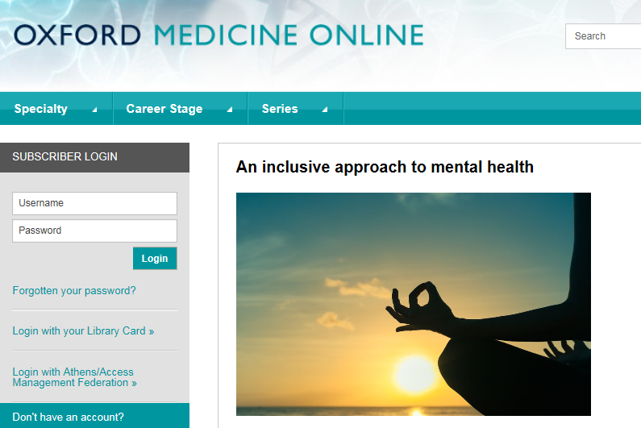
From the homepage you will be able to see the subscriber login box. Do not enter any details in the username and password boxes, instead click on the ‘Login with Athens/Access Management Federation’ link.
Type NHS into the filter box and click on NHS England
You will then be prompted to sign into your Athens account.

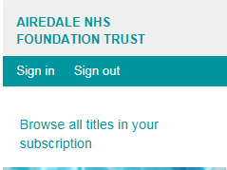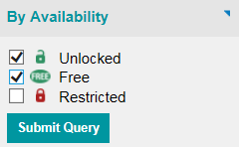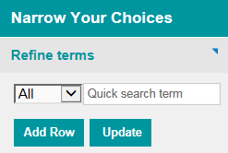
Click on the ‘Browse all titles in your subscription’ link. Then tick the Unlocked and Free boxes under availability and click Submit Query. You can then use the Refine terms box to search for keywords or a full title. You can also browse by speciality.

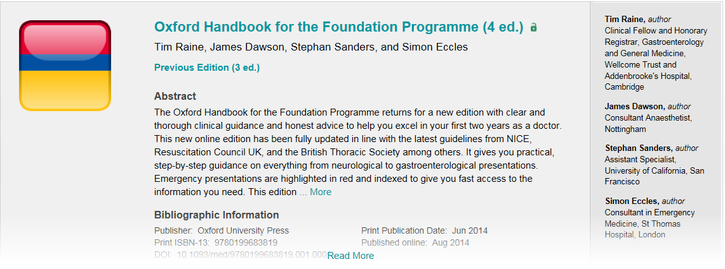
When you select a book you will see the abstract and bibliographic information. If you scroll down you will see the contents. You can then go to individual chapters.
TIP: Holding down the Ctrl key and pressing F when you are in Internet Explorer opens a search box you can use to search for words on the page. This is useful when viewing the chapters as it can help you find what you are looking for more quickly.

If you require any support in accessing one of our e-books, please send us an email, give us a call or visit us in person. Airedale.library@anhst.nhs.uk 01535 294412

