Need Help
Accessing e-books?

The easiest way to access our e-books is to find the link on the library website

Click on the E-Resources tab and then click the E-Books button.
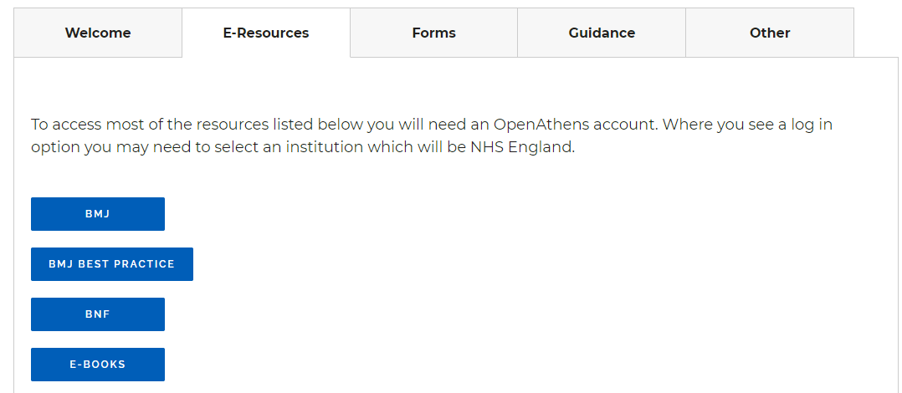
After clicking the link, you will be prompted to sign in with an OpenAthens account.
If you don’t already have an account, you can register for one using your Trust email address. There is a link to register for OpenAthens on the top right of the Library Services page.
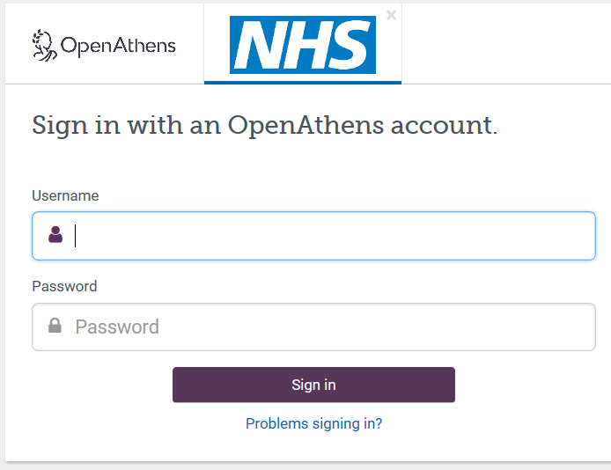
From the home page you will be able to see the search box:
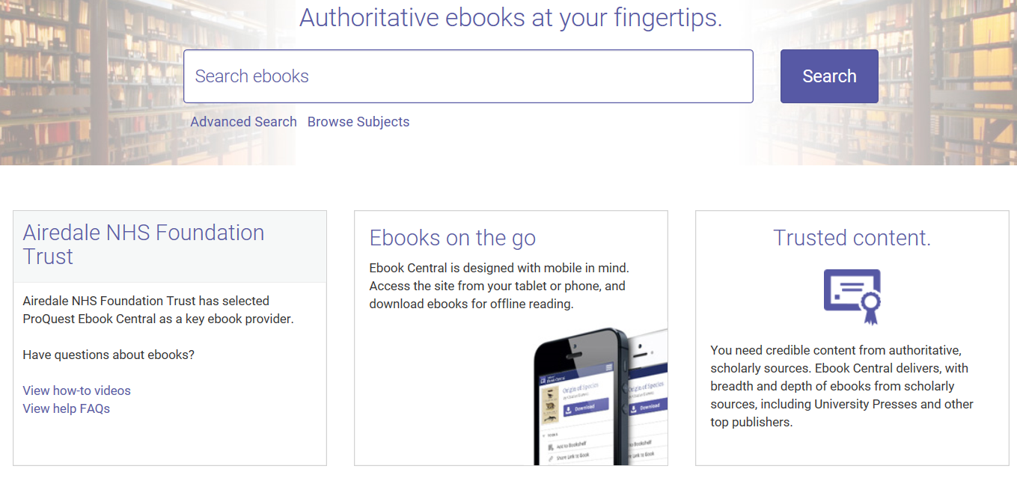
If you have accessed any of our e-books recently, these will be displayed also.
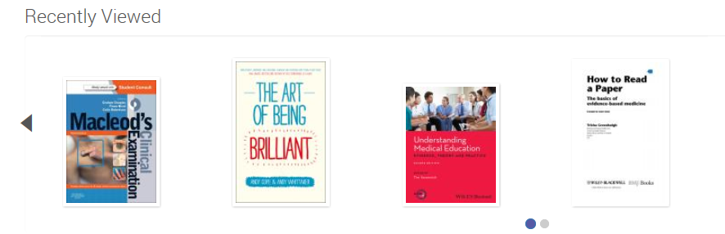
Once you have found a title that you want to read, you have two options, either read the book online or download it. You can download the book for a period of 14 days and you will need to have Adobe Digital Editions installed to view it or transfer it to an e-reader. You will be prompted to download this software when you click the download button. To read online, no additional software is required. A benefit of reading online is that you are able to search within the book for keywords and find where they appear in the text. You can also highlight sections of the text and add your own notes

If there are e-books that you would like to view again or download from our collection in the future, you can save these to view later. You could just have one collection of items you are interested in or several grouped by subject. It is entirely up to you. After searching for an item, click on the ‘Add to bookshelf’ icon which appears as the fourth icon on the right. Then select a folder or create a new one.
